**Mongodb Assignment 1**

mongoDB exercise in MongoDB shell

Insert Document-

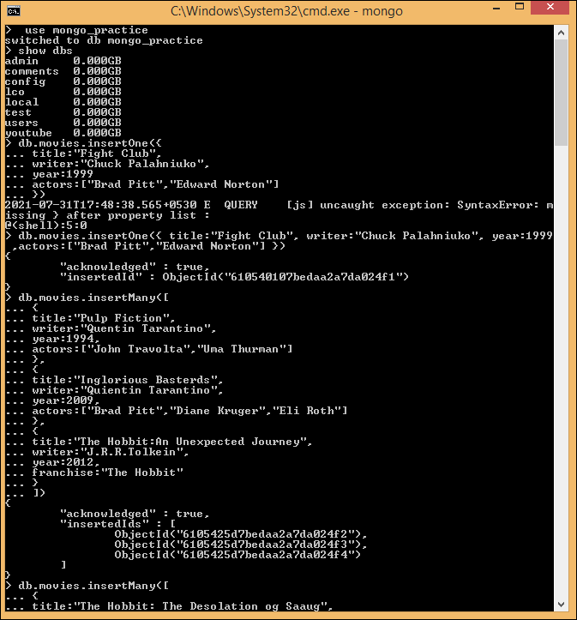

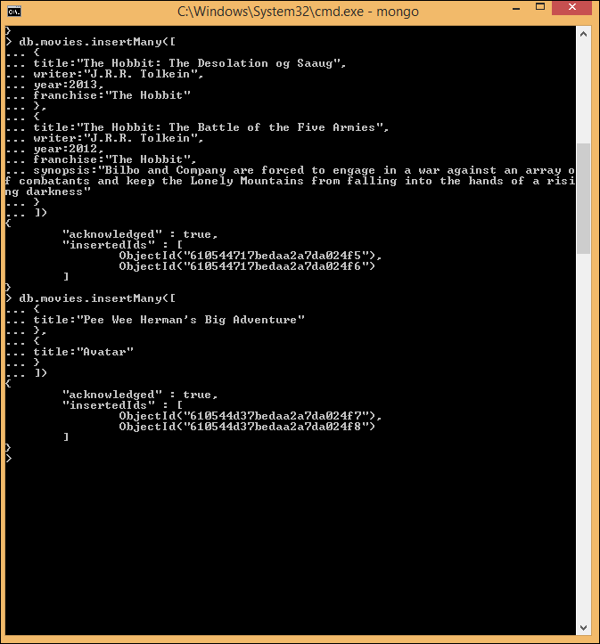

Query/Find document-

1. get all documents-

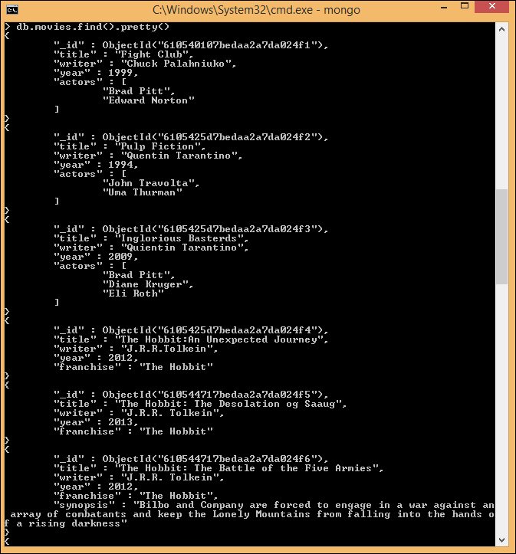

1. Get all documents with writer set to “Quientin Tarantino”
2. Get all documents where actors include “Brad Pitt”
3. Get all documents where franchise set to “The Hobbit”

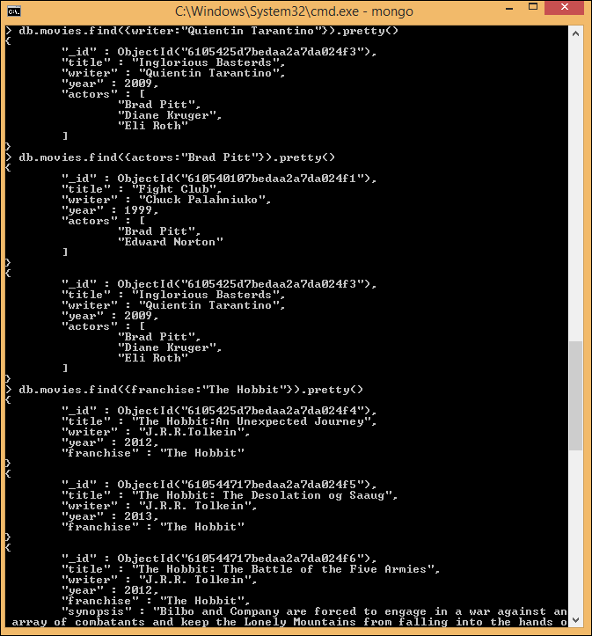

1. Get all movies realeased in 90’s
2. Get all the movies realesed before 2000 or after 2010

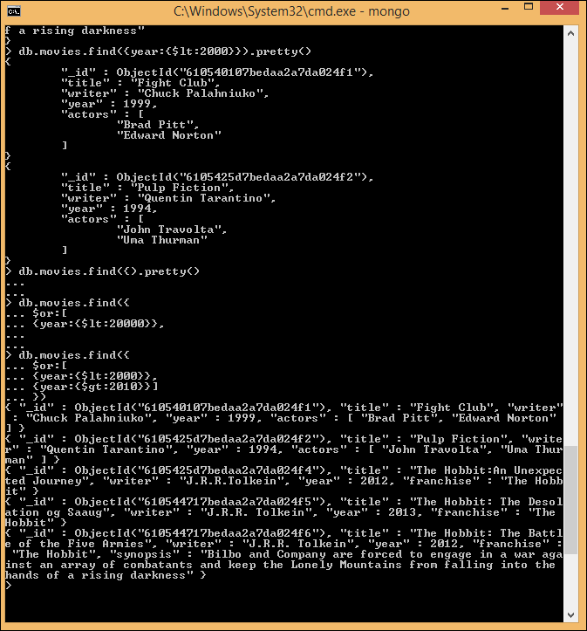

Update Documents-

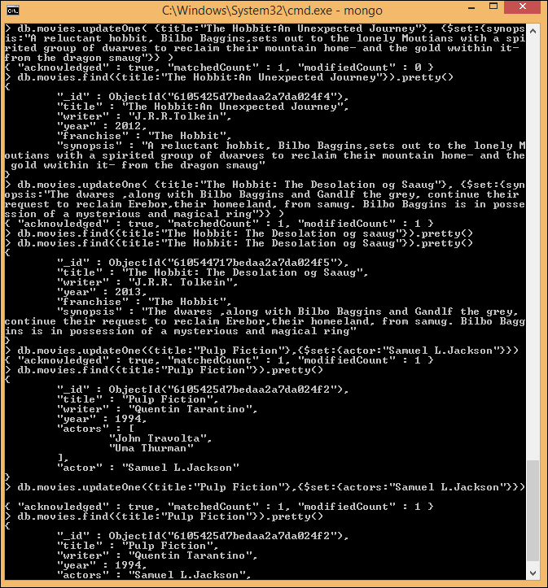

Text Search-

1. Find all movies that have a synopsis that contains the word “Bilbo”

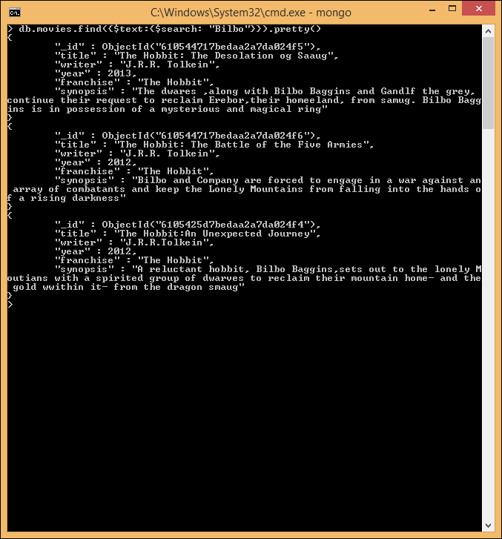

1. Find all movies that have a synopsis that contains the word “Gandlf”

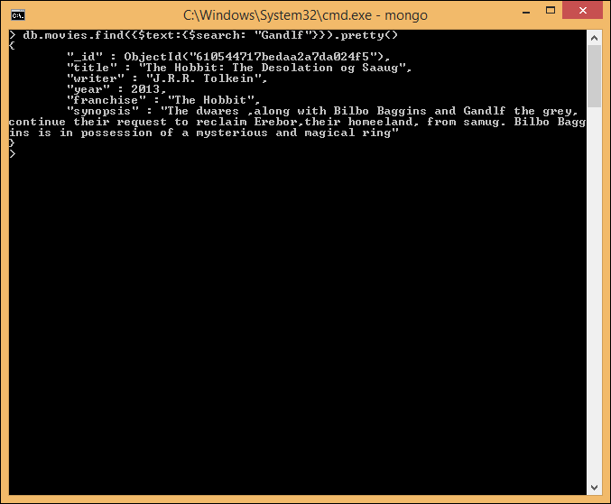

1. Find all movies that have a synopsis that contains the word “Bilbo”and not the word “Gandlf”

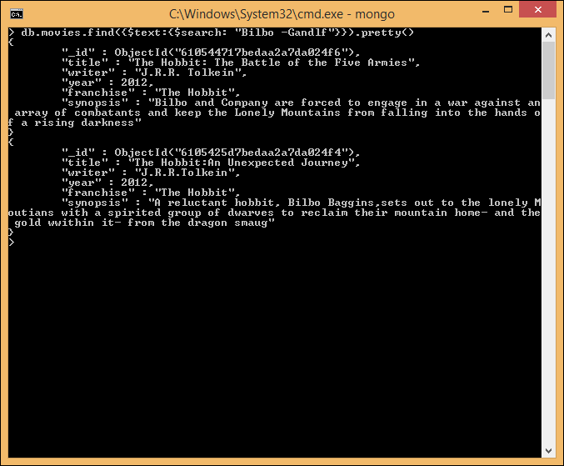

1. Find all movies that have a synopsis that contains the word “dwares”or “hobbit”

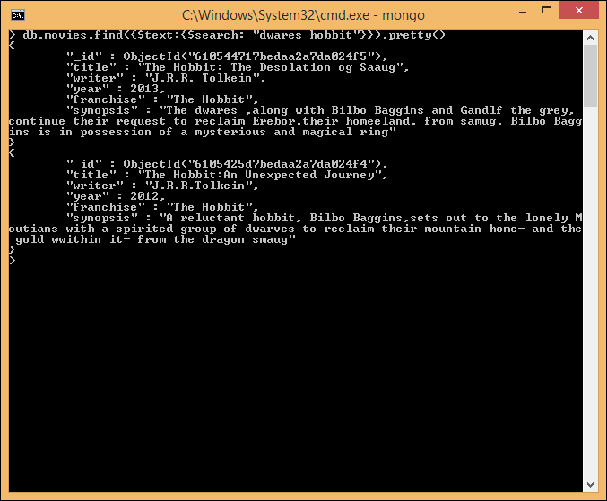

1. Find all movies that have a synopsis that contains the word “gold” and “dragon”

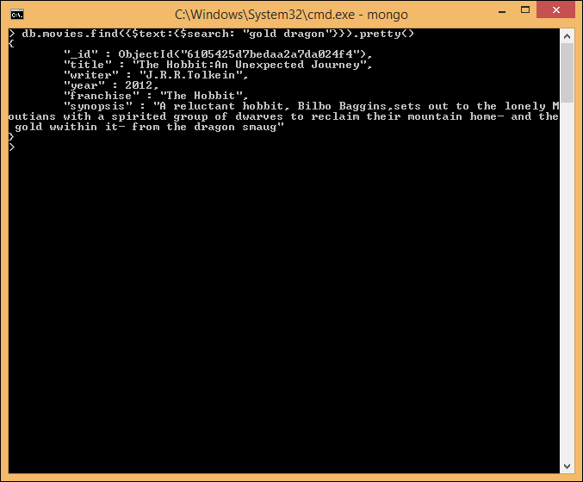

Delete documents

1. Delete the movie “Pee Wee Heramn’s Big adventure”
2. Delete the movie “Avatar”

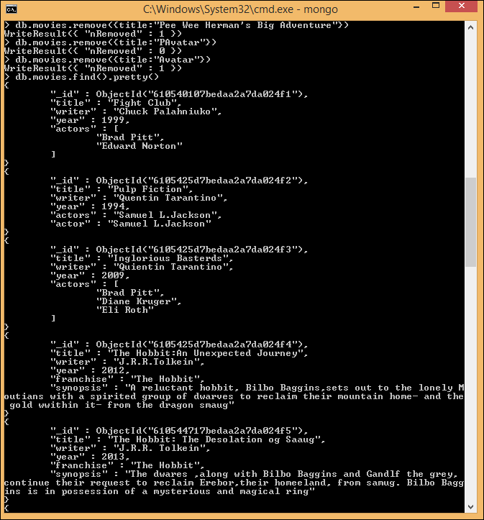

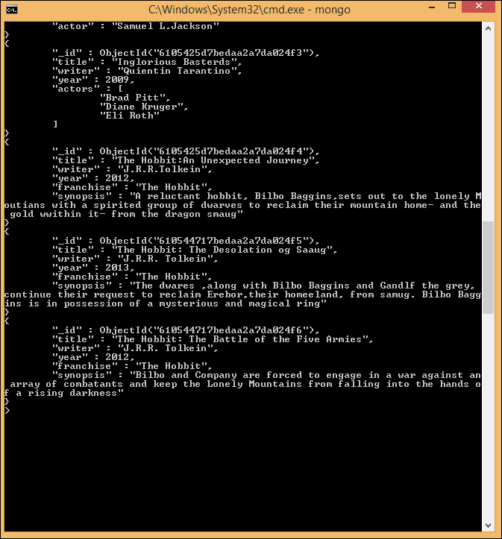

**Relationships-**

Querying related collections

1. Find all users

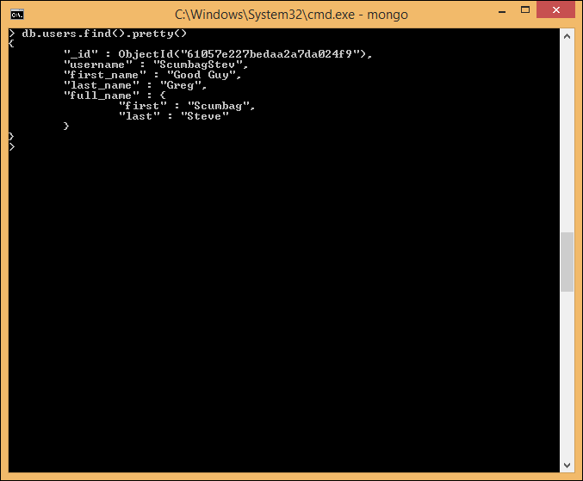

1. Find all posts

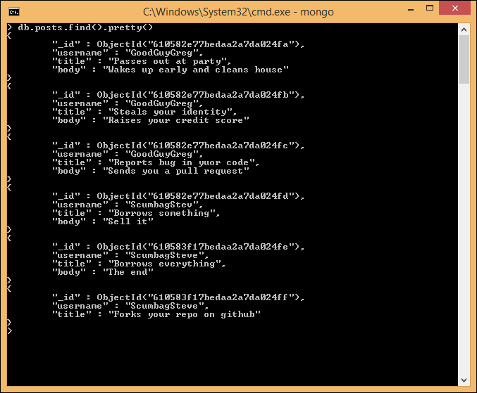

1. Find all posts that was authorised by “GoodGuyGreg”

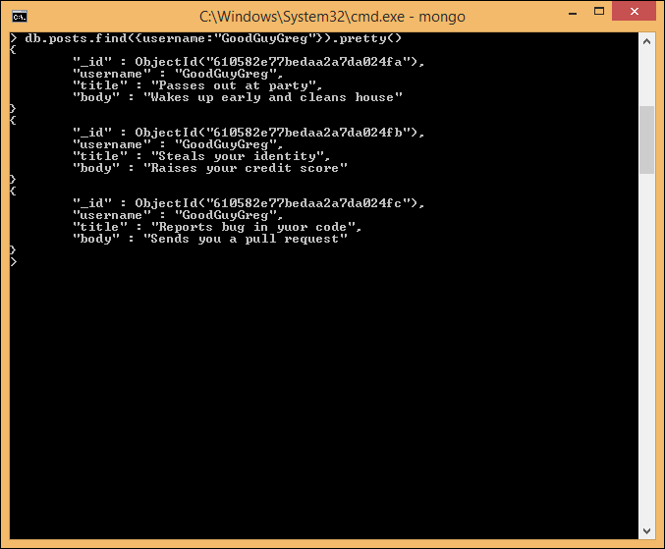

1. Find all posts that was authorised by “ScumbagStev”

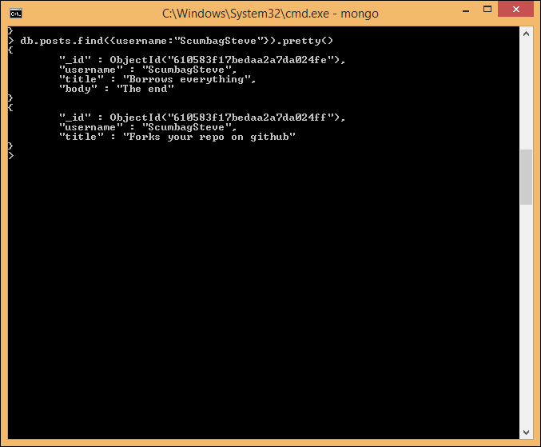

1. Find all comments

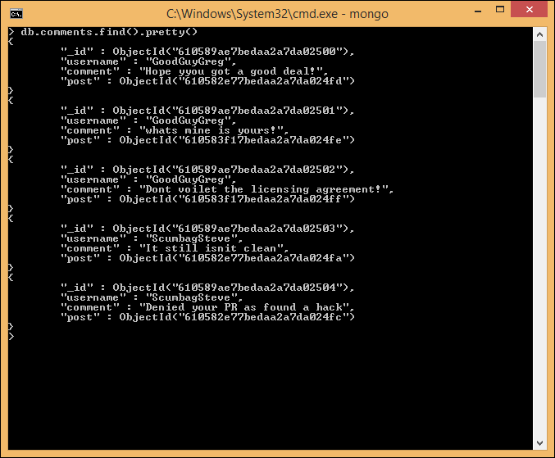

1. Find all comments that was authorised by “GoodGuyGreg”

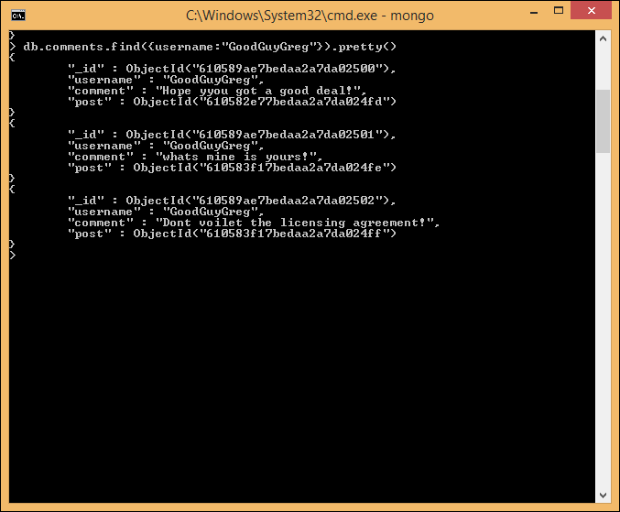

1. Find all comments that was authorised by “ScumbagStev”

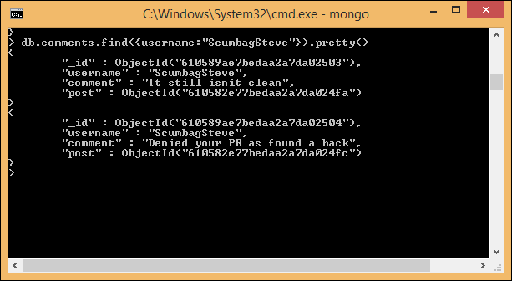

1. Find all comments belonging to the post “reports a bug in your code”

